4.NF.3 /Mrs. Faour Name:___________________________________
Decomposing Fractions into unit Fractions (with a Numerator of 1)

DIRECTIONS: Decompose the fraction so that each part has a numerator of 1

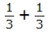
1) = 7)

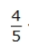
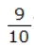
2) 8)

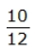
3) 9)

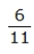
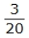
4) 10)

5) 11)

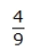
6) 12)

